Orchestration using Data Factory

Delta Load Process

Reference: [Incrementally Load New Files in Azure Data Factory by Looking Up Latest Modified Date in Destination Folder – business intelligist](https://businessintelligist.com/2021/04/29/incrementally-load-new-files-in-azure-data-factory-by-looking-up-latest-modified-date-in-destination-folder/)

Attach the Databricks notebook in the pipeline

Use Get Metadata activity to make a list of all files in the Destination folder



Pipeline parameters

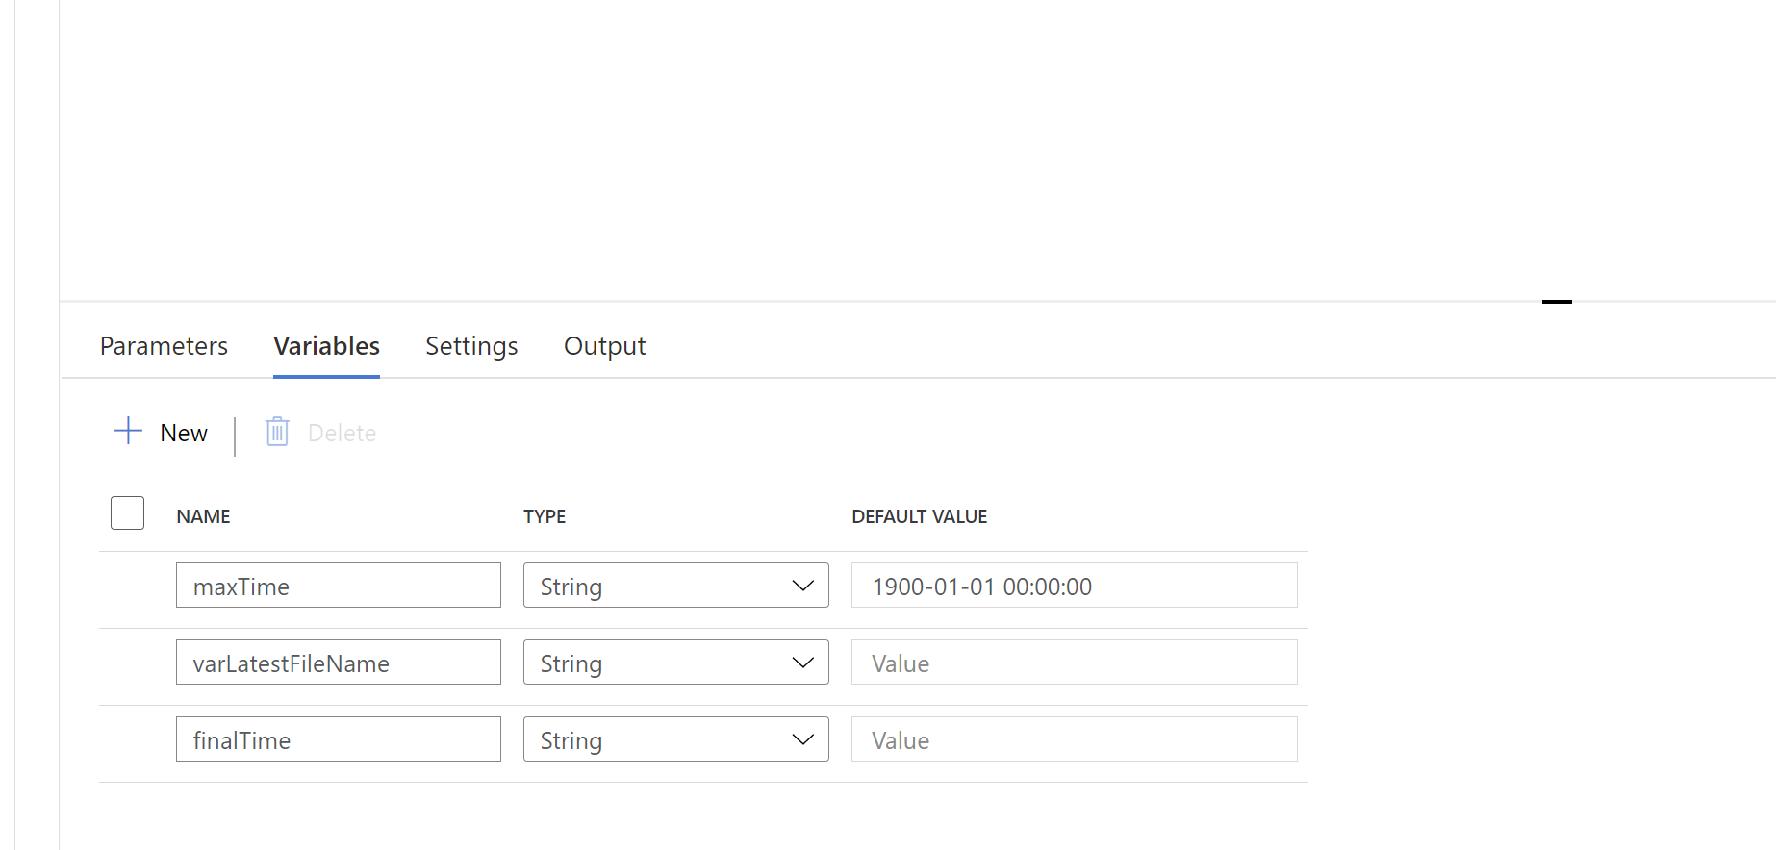

For Each:

@activity('GetParkingOutputDeltaFiles').output.childitems

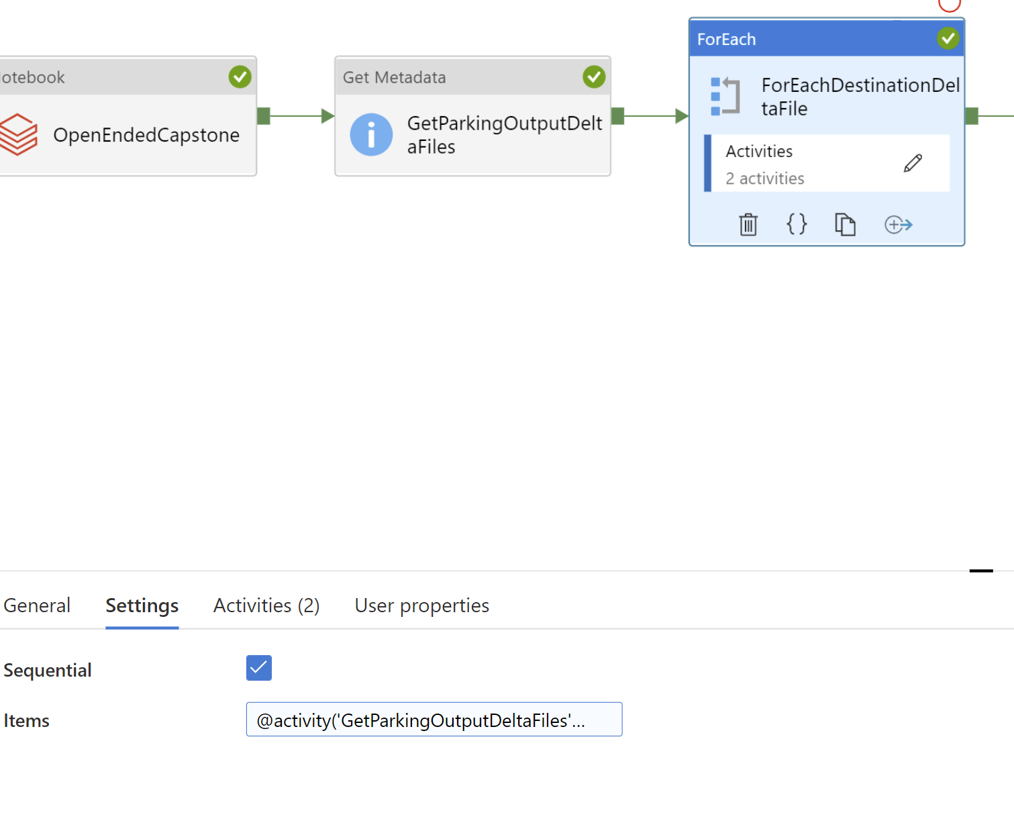

Use For Each activity to iterate this list and compare the modified date with the value stored in a variable



If Condition:

@greater(activity('GetDestinationFileMetadata').output.lastModified,variables('maxTime'))

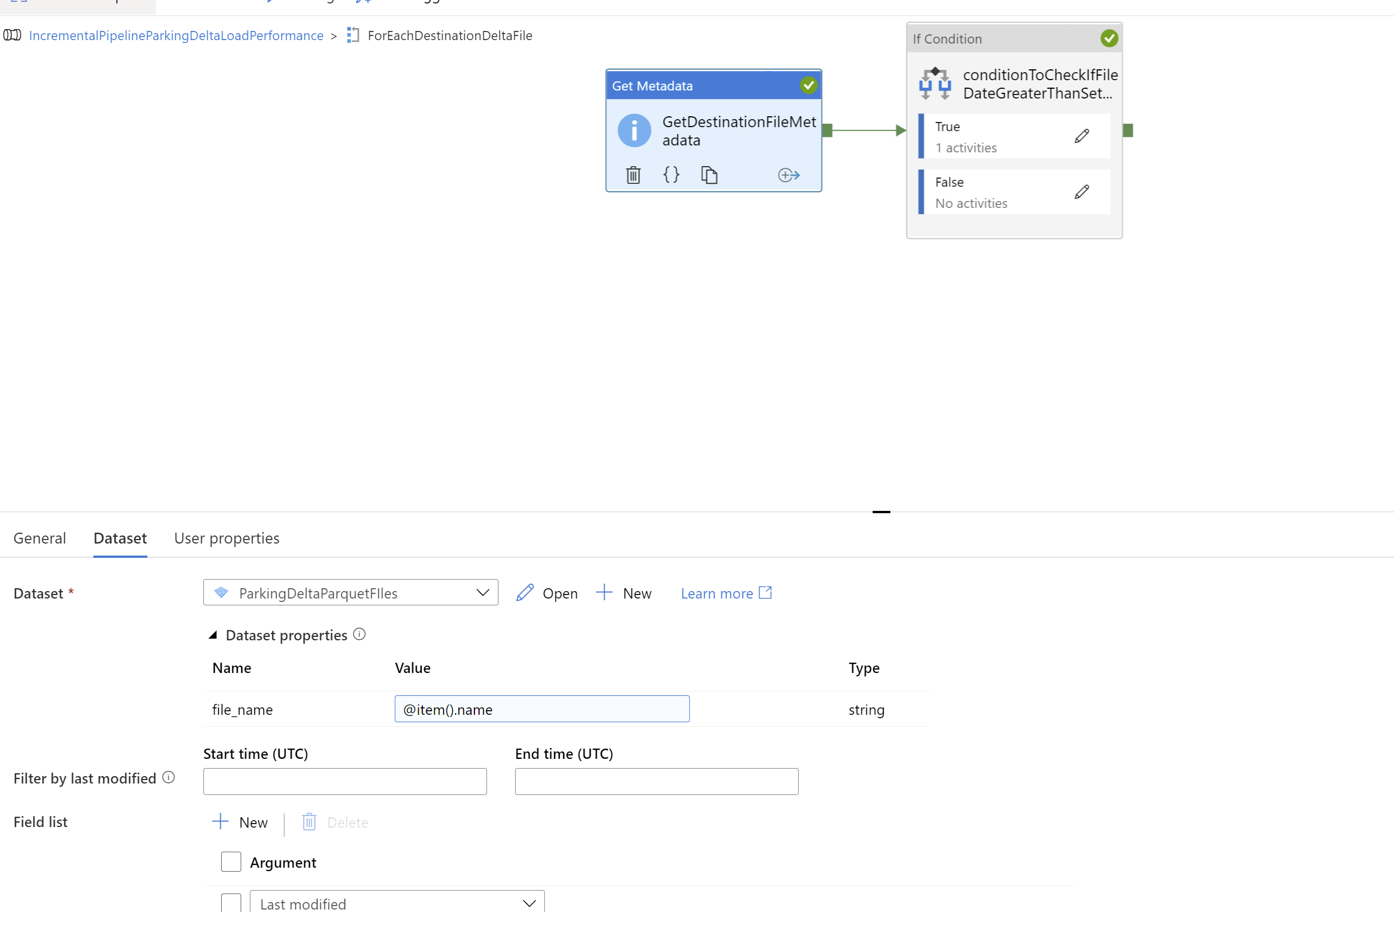

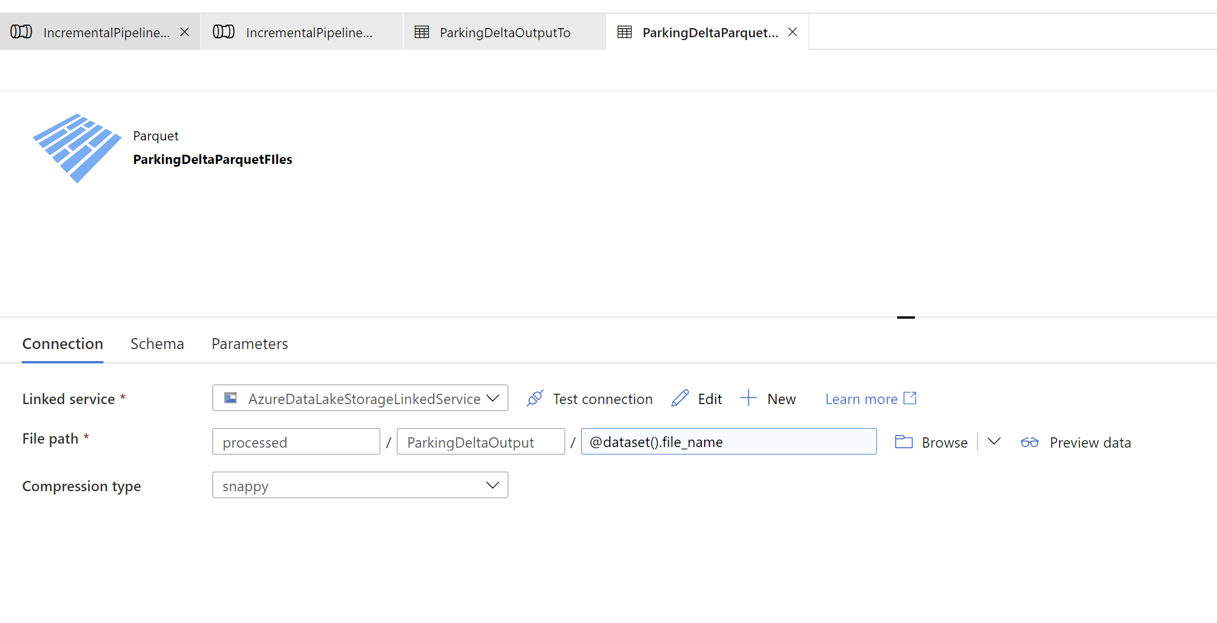

And finally writing into the variable

@activity('GetDestinationFileMetadata').output.lastModified

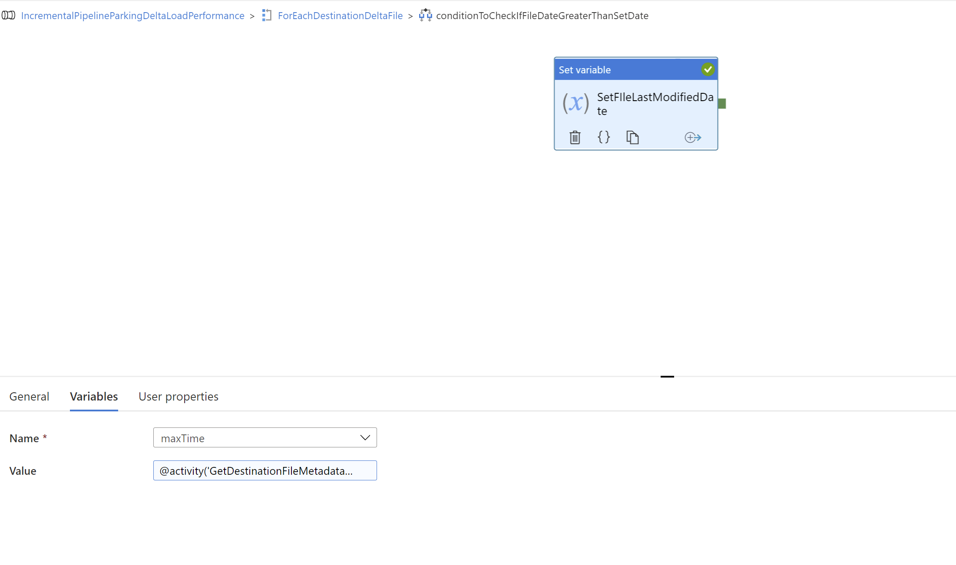

Copy from Delta Source to Destination filtered by maxTime

Source

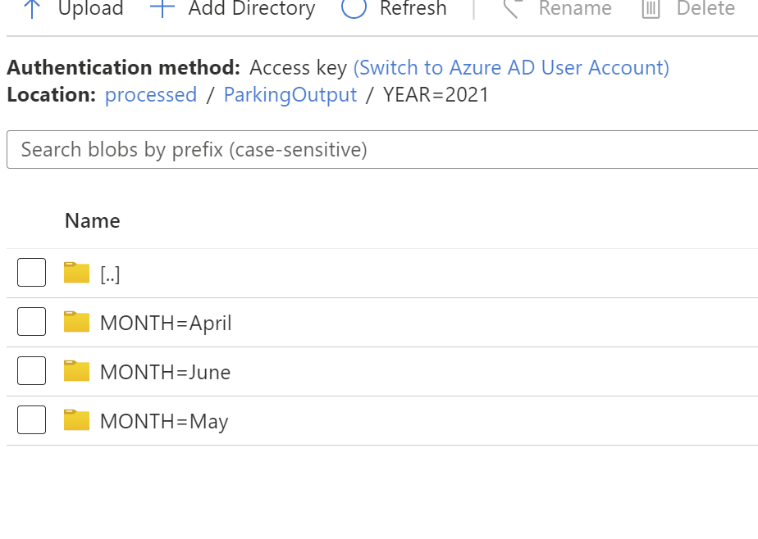

Destination

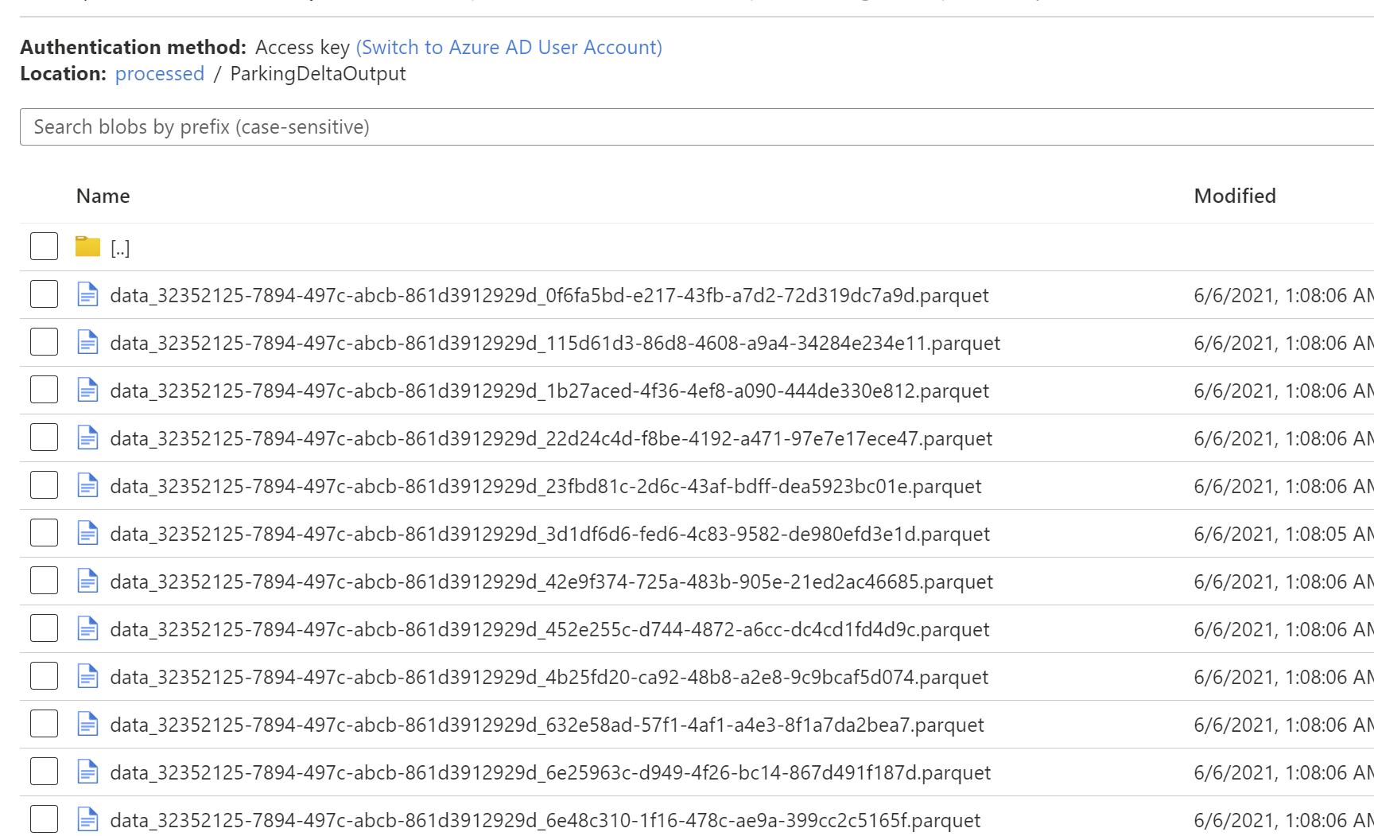

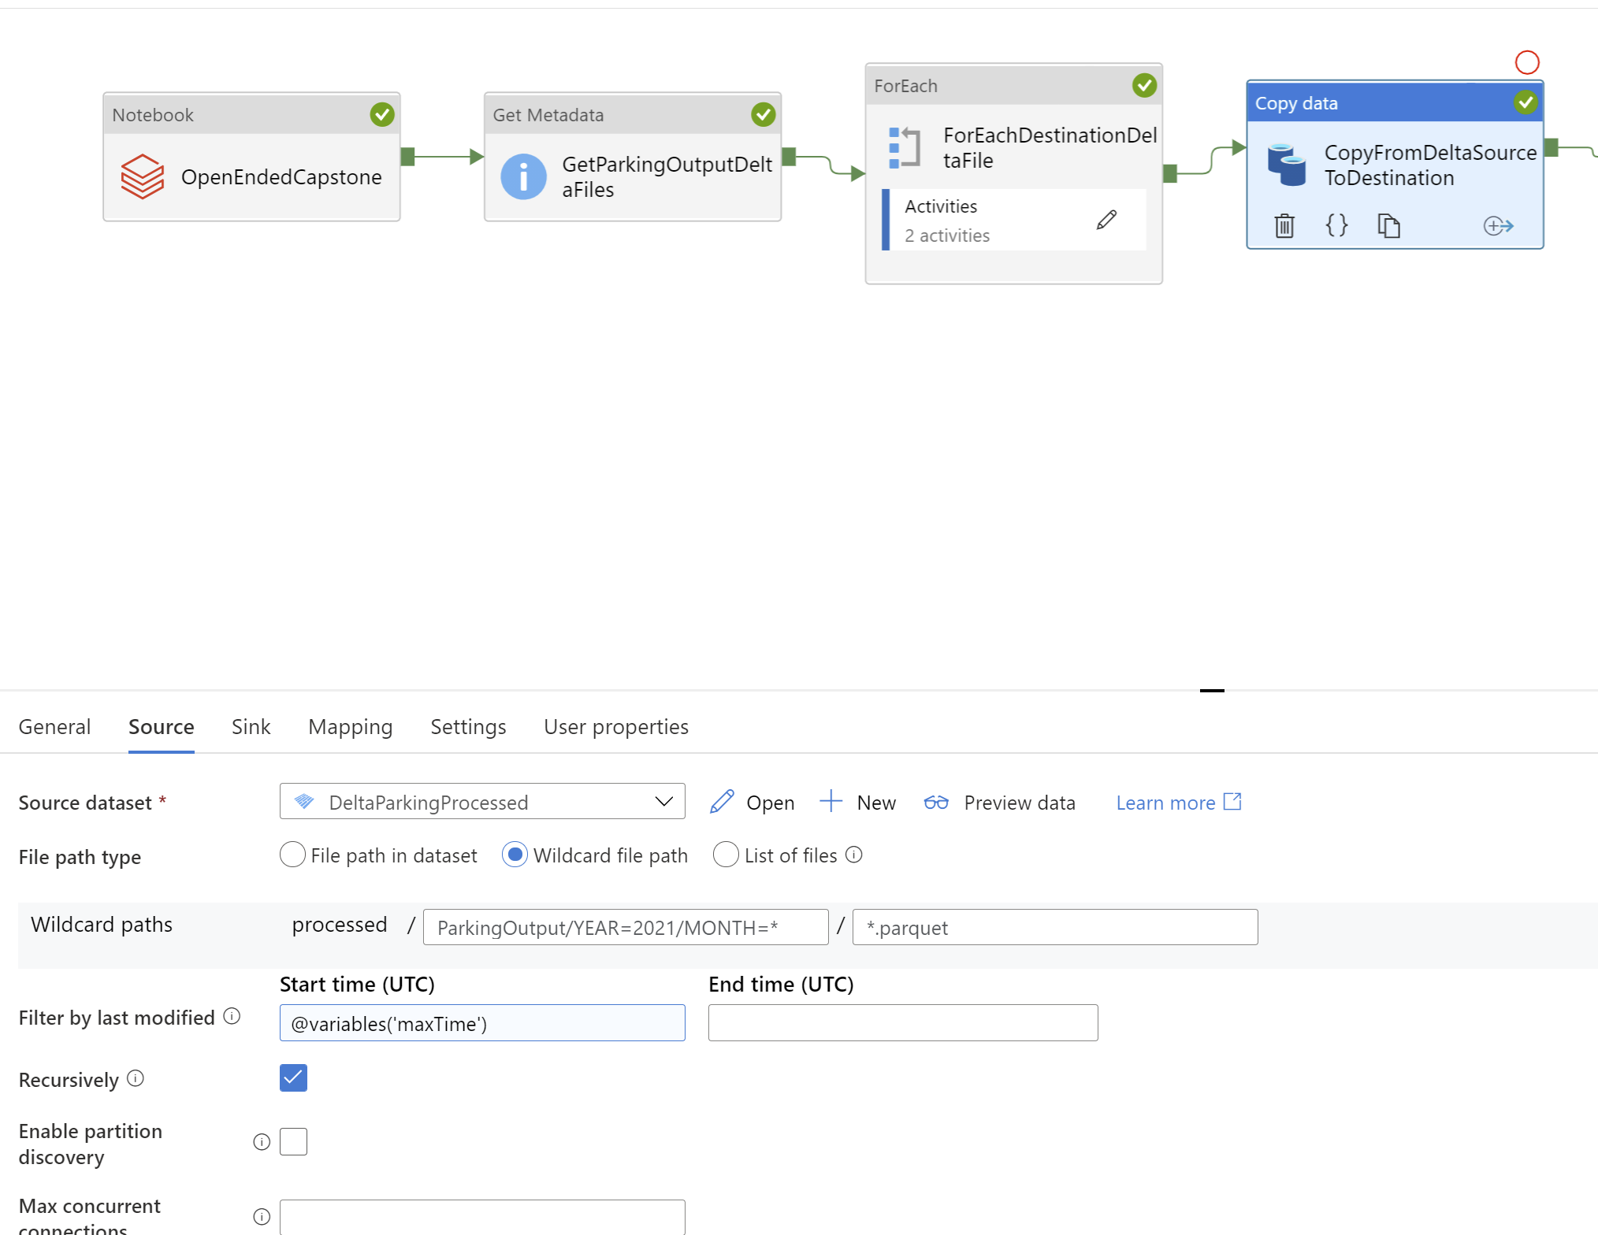

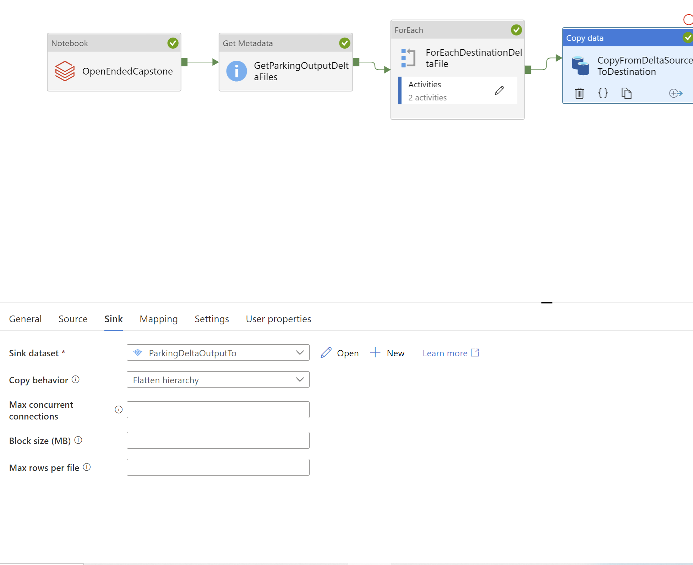

Get Metadata of Destination files:

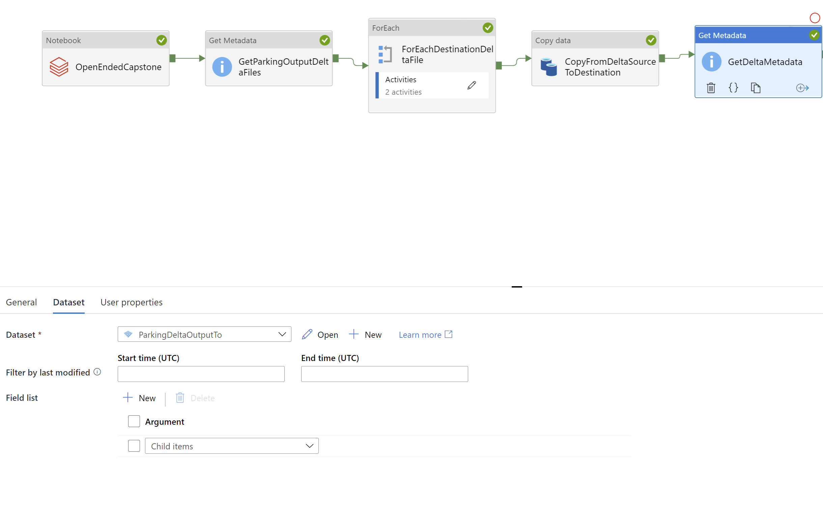

For Each

@activity('GetDeltaMetadata').output.childitems

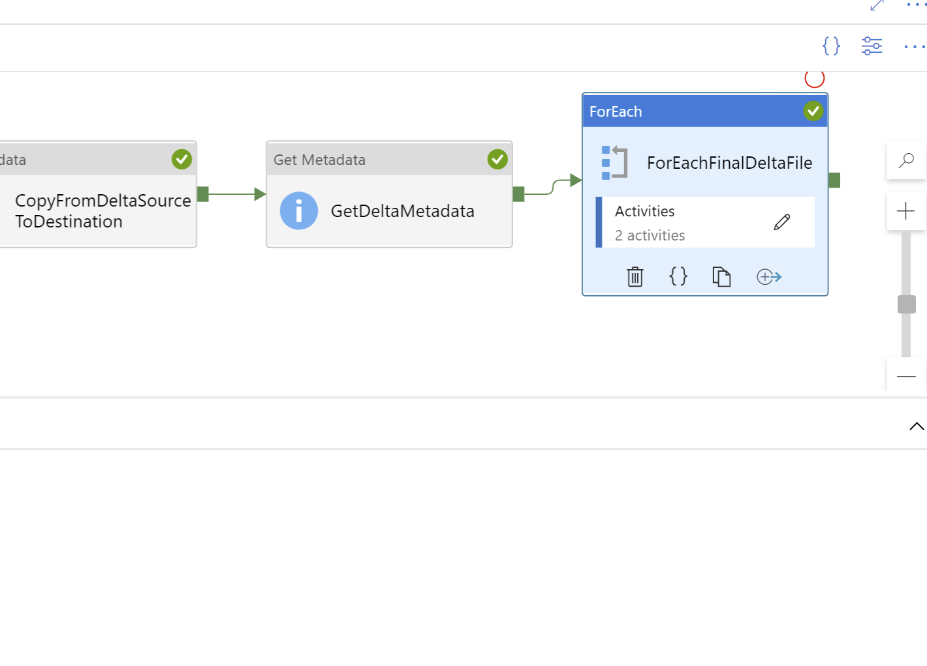

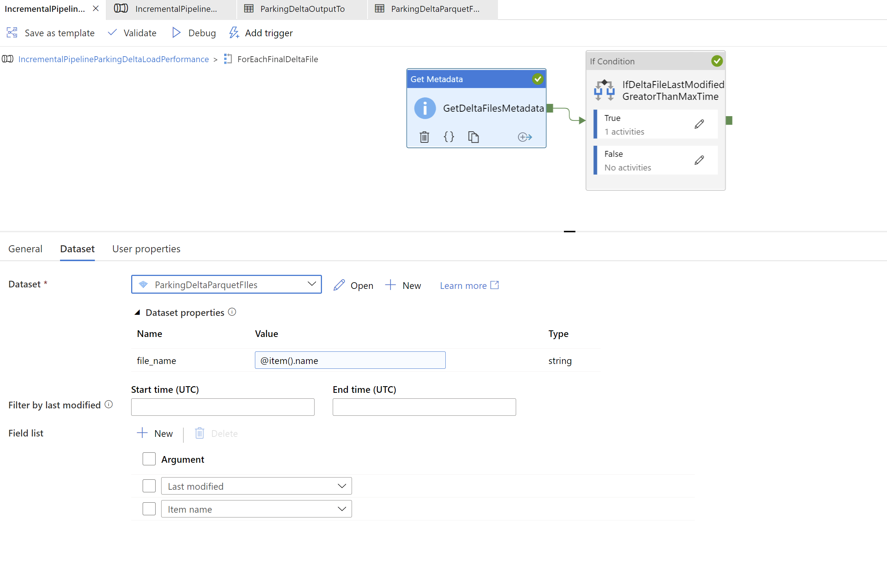

@greater(activity('GetDeltaFIlesMetadata').output.lastModified,variables('maxTime'))

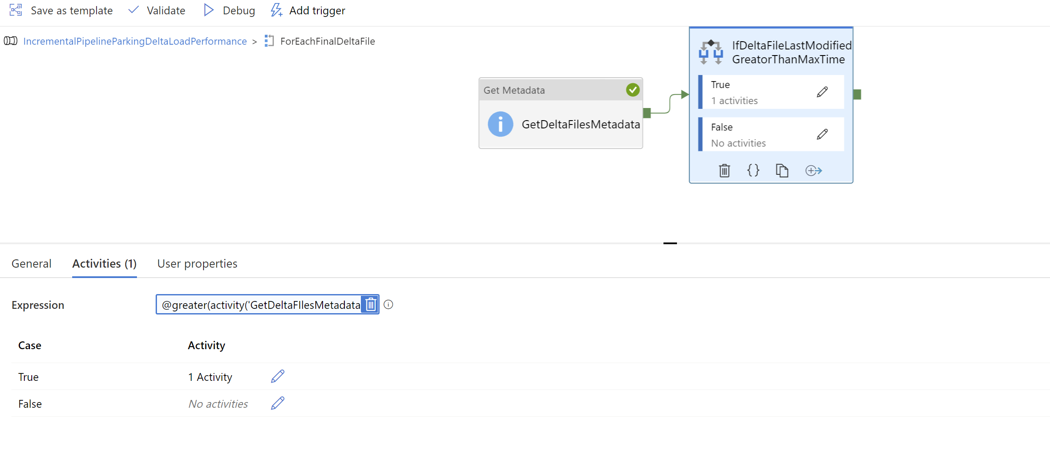

@activity('GetDeltaFilesMetadata').output.itemname

